IOT Door Buzzer & Home Security Device

We live in the 21st century where everything is preferred to be fast contactless and automated. COVID has even more increased the need for contactless systems. Well here we propose a contactless doorbell as well as safety system using IOT for automatic visitor recognition and alerting home owner.
The contactless doorbell uses a raspberry pi controller to work along with a camera module and speaker to perform automatic operations. This system will help home owner know who has arrived at his/her door as well as it will act as a security system when the owner is not at home to alert on any robbery.
This Contactless IOT Doorbell & Safety System provides the following advantages:
- Automatic Visitor Recognition
- Voice Assisted Interface
- Instant Online Alerts on Desktop/Mobile
- Ability to Sound Alarm at remote Location
- Monitor Activity Outside the House at any Time
- Fully Automated System

The raspberry pi system allows for a fully automated doorbell system. The system makes use of a raspberry pi controller to manage the entire working. We hereby use a camera module to capture video and images of any approaching person. The person dosent need to press any button the camera is used to detect any person approaching the door and use face recognition to check if the person is registered in the system or not.

If the person is registered in the system the doorbell greets the person and alerts the owner over IOT about who has arrived along with an image. If the person is not registered in the system the system shows image over IOT and allows the owner to ask a question/post a reply by choosing one in the IOT interface. Based on the Question/reply selected the doorbell system uses text to speech to ask/reply the person what the owner said.

Also the system allows the owner to check live image of the door front anytime through a button press on the IOT interface. Also the system allows user to sound an alert/alarm at the door if owner senses any problem/break-in attempt to alert neighbours.

Components:
- Raspberry Pi
- Camera Module
- Wifi Module
- Speaker
- LCD Display
- Ultrasonic Sensor
- Resistors
- Capacitors
- Buttons & Switches
- Electrical & Wirings
- PCB Board
- Diodes Transistors
- Connectors
- Screws and Fittings

Applications:
- House & Bungalows
- Offices
- Apartments
- Farmhouses

Advantages:
- Automatic Visitor Recognition
- Voice Assisted Interface
- Instant Online Alerts on Desktop/Mobile
- Ability to Sound Alarm at remote Location
- Monitor Activity Outside the House at any Time
- Fully Automated System

Disadvantages:
- The arriving person cannot talk to owner
- Cannot open the door remotely
- Doesn’t auto detect robbery inside home

Block Diagram

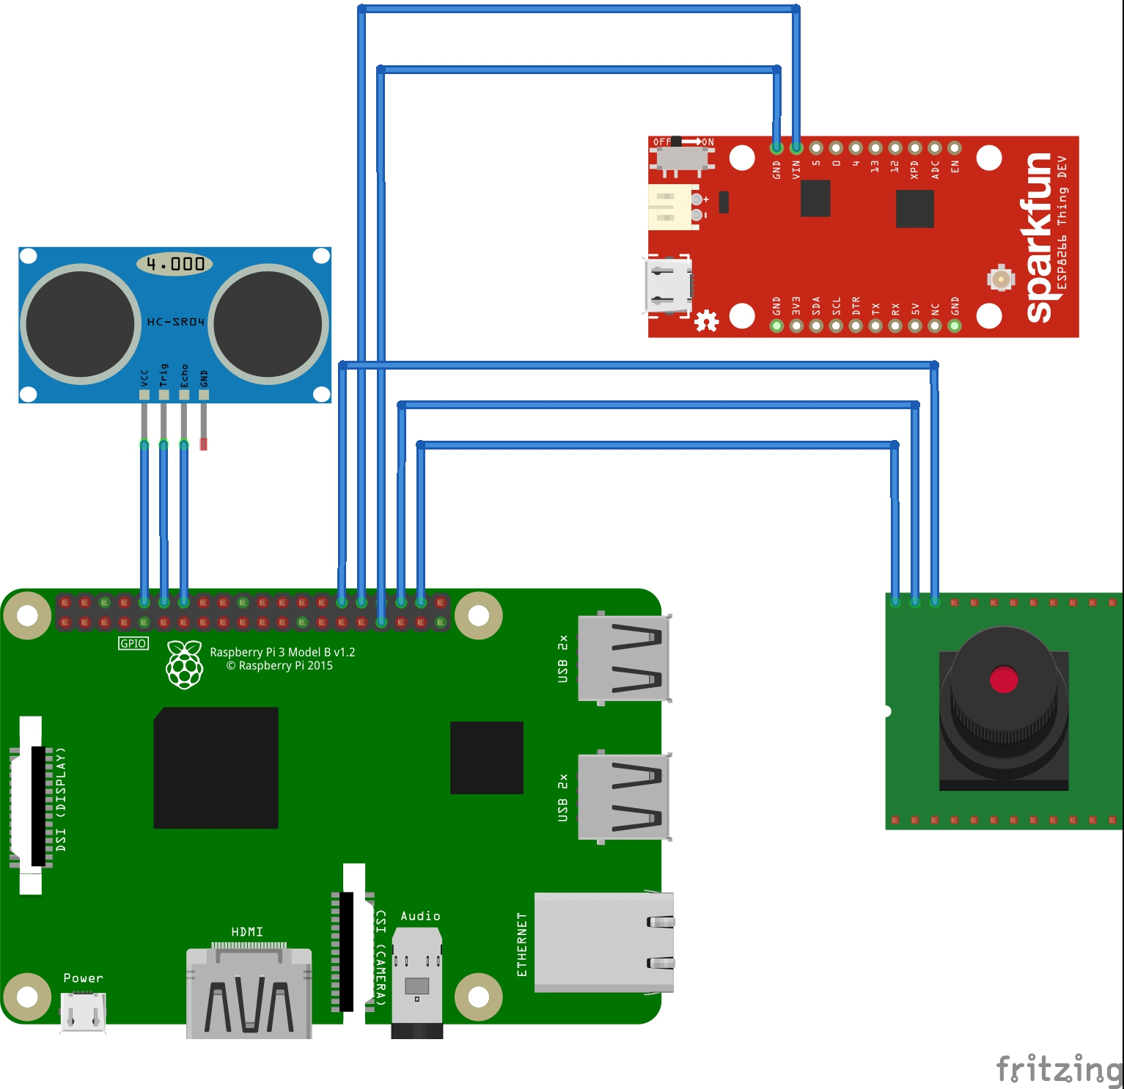

Images
